**Writeup and Visual Analytics**

**Market Size by State and Year**

Hypothesis: Based on the decline/growth on market size from 2012 to 2014, Change Financial can enter into home loans market in the surrounding states of DC. Since It is small regional bank in DC, expansion of new home loans product other states can be profitable.

Following graphs shows the number of loans in each state for three consecutive years. There is the decline in market from 2012 to 2014 for each of the five states. I hypothesize to look for opportunities in surrounding states. DC is not the highest emerging market right now in this business area.

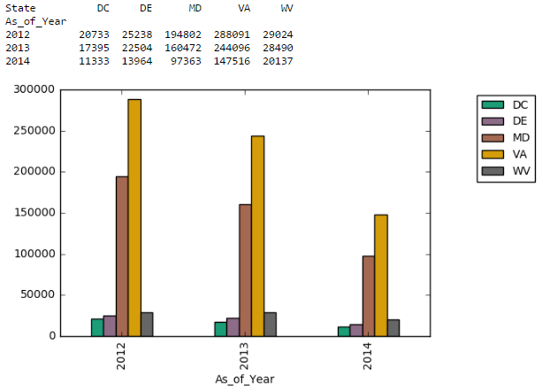

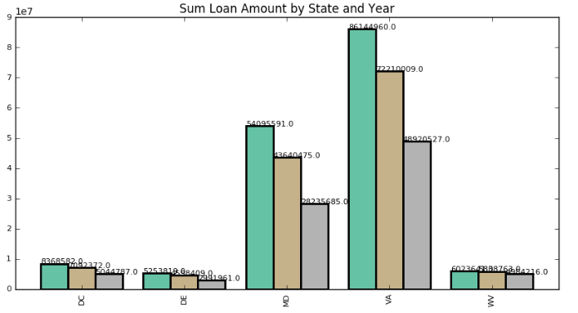

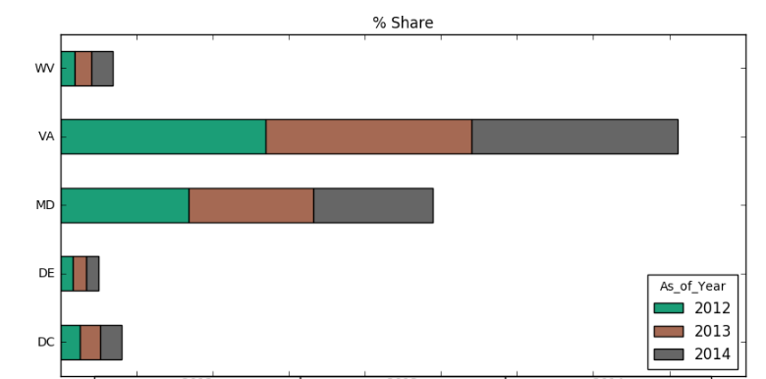

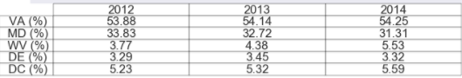

And although the rate of decline in the number of loans originated, the total value of the loans varies from state to state. Over the three years in our data, despite the decline, the largest number of loans originate in Virginia than any of the other states followed by Maryland. That is, loan volume (# of Loans) originating in Virginia have consistently stayed at 54 percent of the total loans through the years while about 33 percent of the loans originate in Maryland.

This proves my hypothesis that change Financial have good growing opportunities in these states.

**Analysis**

Being an information-driven culture for Change Financial, smart strategic move will be, to understand the market first and then target right audience. Lending, in home loans market, is always a risky investment (can be profitable with right strategy), so Change Financial should try and mitigate risk wherever possible.

1.Understand and Choose the Right Product

Change Financial has an option to choose between new homebuyers or refinance customers or both.

Refinance borrowers:

a.Rate-sensitive

b.Willing to shop around for quotes

c.Know what they are doing

New Homebuyers:

a.Looking for someone to guide them through the process

b.Willing to pay more for established institutes

c.Referral driven

They should focus towards Refinance Market because of the following reasons:

a. The loan amount would be relatively small

b. Risk associated with this market is relatively lower as they can see the track record of the borrower before lending

c. Considering small regional bank and low brand awareness, referrals is not a strong point at initial stage for new acquisitions.

- They should target towards conforming and conventional loans because of the following reasons:

a. Conforming loans are governed by Fannie Mae and Freddie Mac guidelines which makes them less risky. Doing so, the bank can always sell the loan to them to have enough security to work with more borrowers.

b. Dealing with conventional loans, the bank knows that the borrower has a good credit history, stable income and can make a sizable down payment (~20%).

2. Target Audience

Having too broad of an audience will negatively impact Change Financial's investment. Above loan metrics analysis by state and year can be narrowed down to focus potential clients rather than full audience.

-Since Change Financial is a small regional bank headquartered in Washington, DC, and has branches in surrounding states, loan volume for refinance borrowers would help decision makers to focus on 2/3 target states.

-Since homes loans market is sensitive to area and property value, further breakdown of geographical region into top N counties/MSD helps to create focused approach.

3. Strategy

-After finding right geographical area, competitor analysis is needed in order to enter into established market to provide leading indicators for market design and offers.

4. Further Enhancement

- According to survey report of consumer finance 2016 (http://files.consumerfinance.gov/f/documents/201605_cfpb_nsm-technical-report-16-01.pdf), consumer and household demographics provides deeper insights and can be used along with loans data to identify patterns based on geographies in terms of age, educational level, income, household size etc.

-Historical HMDA data for previous few years can provide more conclusion on new home buying patterns and expansion into wider market.

**STEP 1. Understand and Choose the Right Product**

1. Between 2012 and 2014 we can see that the share of Refinance Loans is approximately 64% of total loan volume. Assuming the trend continues and given the benefits of refinance loans and its total share in home loans market, we seem to find better opportunity window in that sector over the next few years.

2. At the same time, considering approximately 36% of the purchase loans from 2012 to 2014, marketing opportunities promoting refinance options are also strong, given the good chances of those customers considering this option, based on offer rate(which is one of the most common reason to refinance for customers) and from Change Financial's market penetration point, this would be good, due to less risk associated and empowering them to make changes to original mortgage terms.

3. Apart from loan volume, second graph which indicates 'Average Loan Amount by Loan Purpose' shows, the Average Loan Amount of ~217K for refinance, which is smaller than ~323k for purchase. Based on our early assumption, that Change Financial is considerably a smaller financial institution as compared to major ones like Capital one, Wells Fargo etc.; capturing loans with smaller average loan amount (with smaller risk and greater flexibility over loan terms) can be a good strategy in growing number of customers hence increasing the profit.

**# of Loans by Loan Purpose**

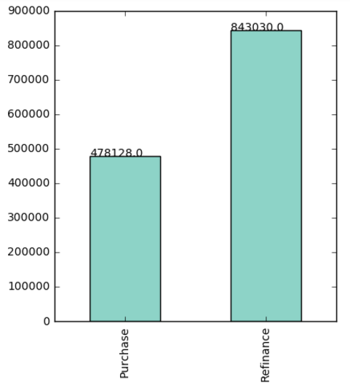

**Purchase vs Refinance**

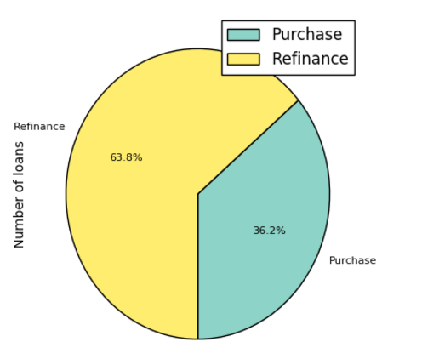

**Mean Loan Amount by Loan Purpose**

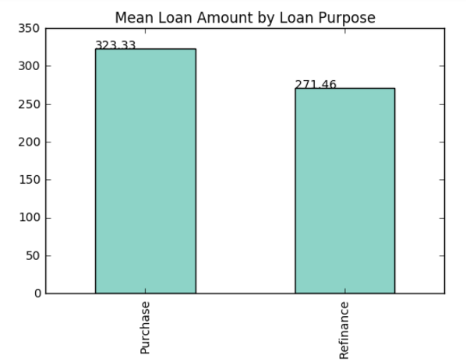

**Conventional/Conforming Loans**

1. Conventional mortgages are all loans that are not made or guaranteed by the U.S. government.

2. Conforming loans are governed by Fannie Mae and Freddie Mac guidelines which makes them less risky.

3. Conforming mortgages are eligible for purchase by Fannie Mae (Federal National Mortgage Association) and Freddie Mac (Federal Home Loan Mortgage Corporation). Therefore, Change Financial can always sell the loan to them to have enough security to work with more borrowers.

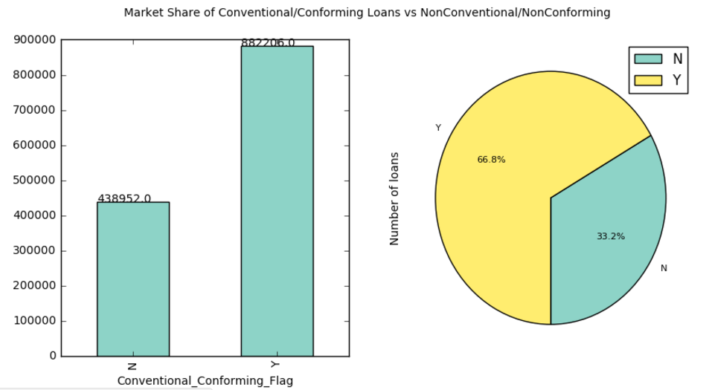

~67% of the total loans are conventional conforming loans along with covering half of the total loan amounts in the homes loan market.

Looking at the distribution of share of "Conventional Conforming " refinance loans in the below graph, Change Financial will be already covering major portion of audience and at the same time less riskier ones.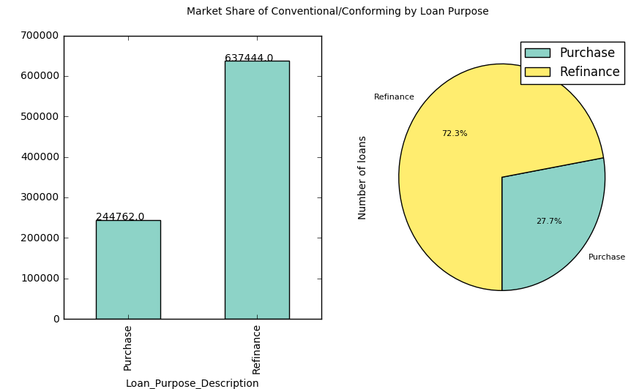

**STEP 2: Target Audience**

Breakdown of Conforming Conventional Refinance loans for all the states shows their market share. Considering Change Financial approach to focus on surrounding states, Virginia and Maryland will be good options.

Over the three years in our data, despite the decline, the largest number of loans originate in Virginia than any of the other states followed by Maryland.

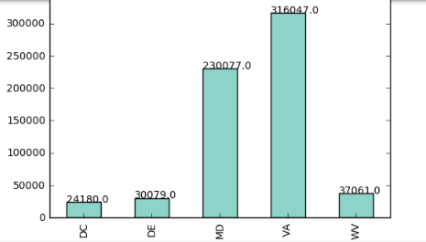

Since we know Home Loans market is sensitive to location, hence we are narrowing down to the top counties in the above identified states.

Not all counties can provide us good business, we explore top 10 counties in each state of Virginia and Maryland in below graphs.

In Virginia, ~62% of the loans are concentrated in just 3 counties, similarly ~55% for Maryland. Since major portion of the loans originate in three counties in each state, we already narrowed our market geographic to much smaller and focused areas. Now it would be easier for Change Financial to target these audiences in most strategic manner.

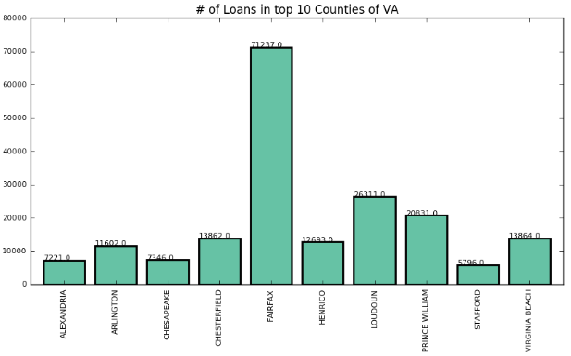

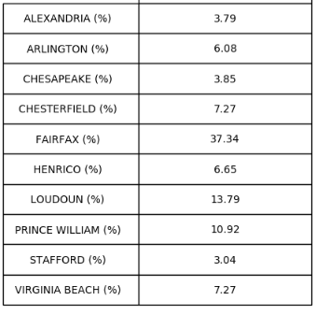

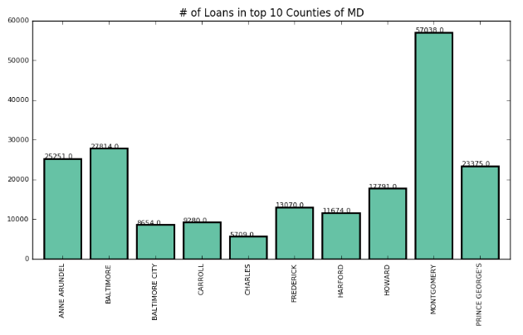

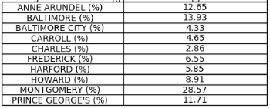

**STEP 3: Strategy**

With growing number of competitors and innovative/flexible housing loans products, home loans sector has been increasingly market driven. Since Competition needs to be measured to design more aggressive plans and pricing.

The three biggest US mortgage lenders controls ~50% of the Refinance market for conforming and conventional loans.

While maintaining competitive rates in the markets, smaller processing costs and faster processing of applications for smaller emerging banks would be an added advantage to attract borrowers.

Also, competitive analysis will help Change Financial to ultimately track down demands for refinance.